GPS Simulator

# Overview

This program sends GPS NMEA-0183 GPRMC and GPGLL sentences out the serial comm port at 4800 baud. The RS232 comm port (J14) is connected to UART 0 on the MCU. The MCU ports and pins are RxD: P11, pin 45; TxD: P12, pin 44.

Two sentences (GPRMC and GPGLL) are sent roughly every second, unless switch S3 is pressed, in which case the code sends messages as fast as possible (about eight sentences per second).

Connect the GPS simulator RDK to your decoder RDK as shown in the figures below.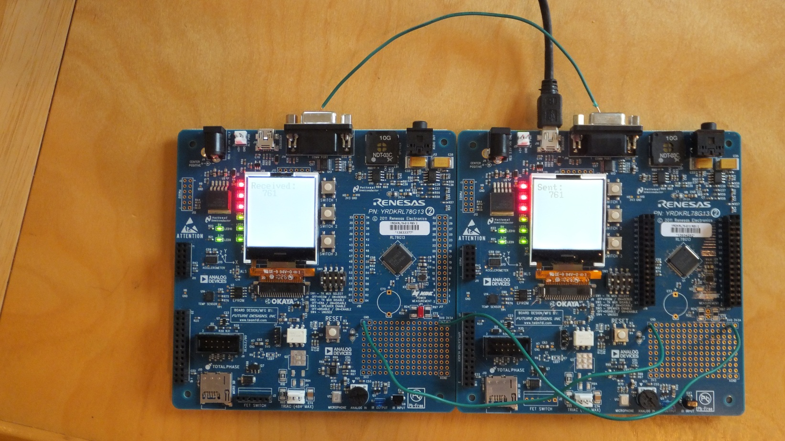

Figure . Overview of two RDKs. The right board is transmitter board running GPS Simulator program, while the left board is receiver which will decode the messages. The right board is powered from USB cable, and the left board is powered through wires connected to GND and 5V0 pads in prototyping area.

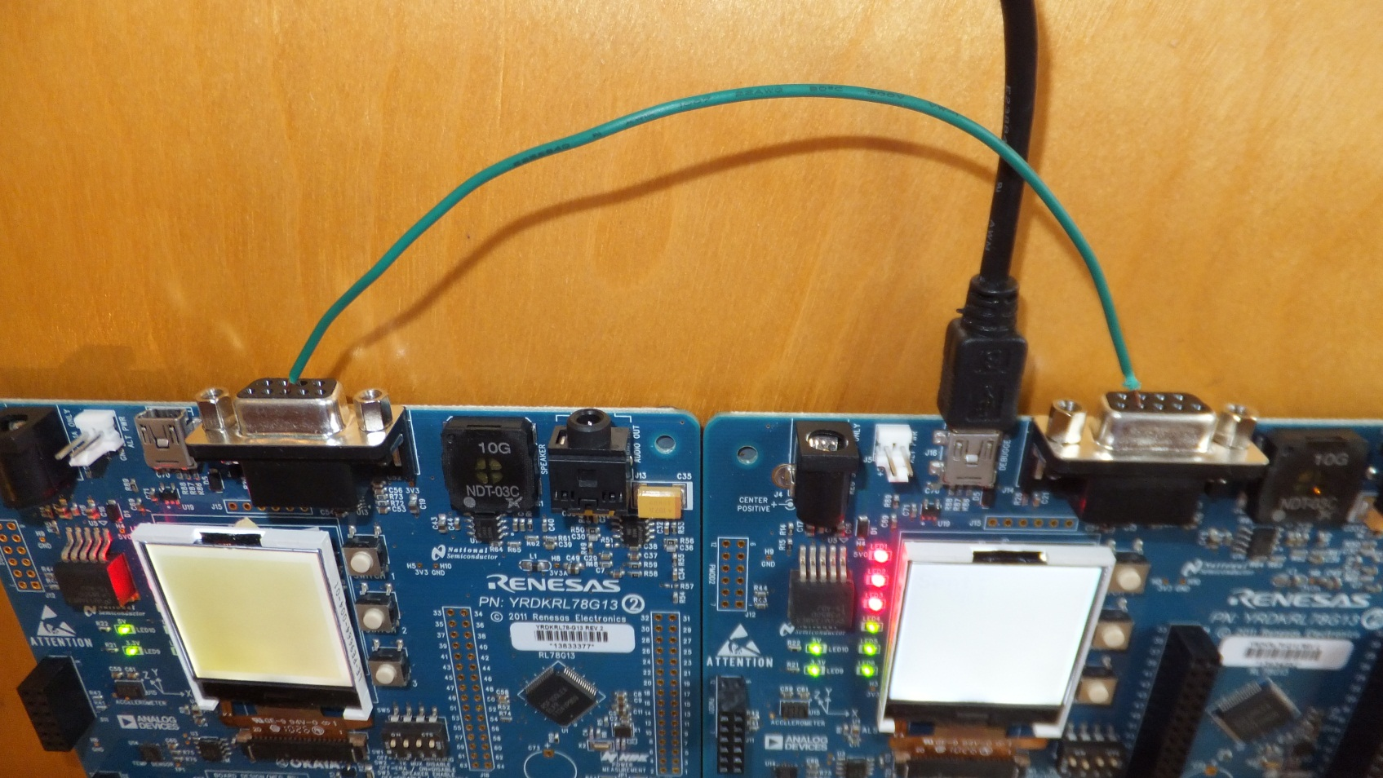

Figure 2. Detail from back showing J14 RS232 transmit data signal (pin 2 on right board (transmitter) connected to Rx Data signal pin 3 on left board (receiver).